Created by: David Rubio G.
Blog: https://soceame.wordpress.com/
GitHub: https://github.com/DRubioG
Last modification date: 04/03/25

You may have been programming in the 2008 standard in Vivado and Vivado recognized that it is from the 2008 standard but showed it as an error. Now I will explain how to change the standard.
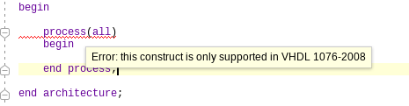
If this has happened to you, it is because you are working with the 2008 standard but Vivado is configured with another standard ('87/'93). To change the standard you have to go to the file's 'Properties'.
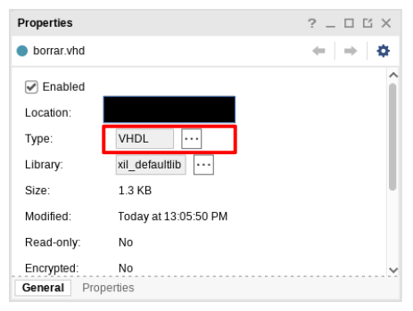
and in the ‘Type‘ field put the new standard you want to use
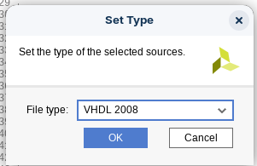
Then the error is gone and you can continue using the new standard.
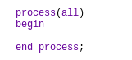
This standard change can be applied to different standards supported by Vivado (from VHDL only to VHDL pre-2008 and VHDL 2008).

